SOLVE AND INTERPRET LINEAR SYSTEMS…BY GRAPHING

Example:
Galaxy Video rents a game machine for $10 and video games for $3 each.
4-Less Video rents a game machine for $7 and video games for $4 each.

- Write an equation to represent the cost of renting one game machine and video games at each store. Define your variables.

- Create a table of values for each equation. (Use a maximum number of 6 video games.)
g | C = | Plot
0
2
4
6
g | C = | Plot
0
2
4
6

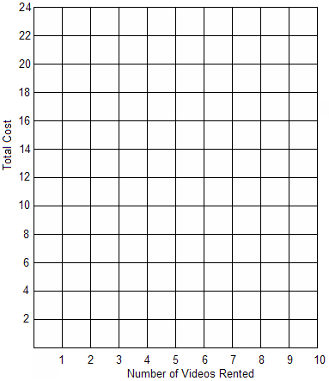

- Graph the two equations on the same set of axes.

- What does the point of intersection represent?

- Describe the situation when each
video store is less expensive than
The other.

Example
- Each graph compares the rental costs of two halls. For each graph:
  - Describe what the point of intersection represents.
  - For how many guests is each hall cheaper? Explain

a) Hall Rental Costs | b) Hall Rental Costs
  5 000  4 000  3 000  2 000  1 000  0  100  200  Number of Guests  Cost ($)  Hall D  Hall C  (150, 4500) | 25 000  20 000  15 000  10 000  5 000  0  200  400  Number of Guests  Cost ($)  Hall F  Hall E  (240, 18 000)

- This graph represents the costs to produce and sell pizza. Graph A represents the daily cost to produce pizza. Graph B represents the daily income from the sale of pizzas.

- Describe what the point of intersection represents
10
0
200
400
Number of Pizzas
Cost and Income ($)
A
B
(30, 350)
600
20
30
40
50
Cost of Pizzas

- How many pizzas must be sold before
there is a profit (that is, the income is
greater than the cost)? Explain.

